SEEDLESS VASCULAR PLANTS

This group includes the Club Mosses (Phylum Lycophyta), Horsetails (Phylum Sphenophyta), and Ferns (Phylum Pterophyta). These are very ancient plants that were prevalent during the Carboniferous period of Earth formation.
The SPOROPHYTE IS DOMINANT in the Seedless Vascular Plants, Meaning that they spend slightly more time as a sporophyte than a gametophyte. The sporophyte has adaptations to help it survive the harsh conditions of land, such as a VASCULAR SYSTEM and WIND DISPERSED SPORES (don’t need water). The spores will germinate and produce a small gametophyte generation. The gametophyte generation retains properties that are not adapted for land, such as NO VASCULAR SYSTEM and FLAGELLATED SPERM.

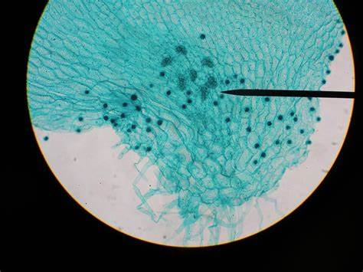
STRUCTURE: ENTIRE
PROTHALIUM
Domain: Eukarya
Kingdom: Plantae
Group: Polypodiophyta
Phylum: Ptreidophyta
Genus:Prothallus

STRUCTURE: ANTHERIDIA
(Located on Prothalium)
Domain: Eukarya
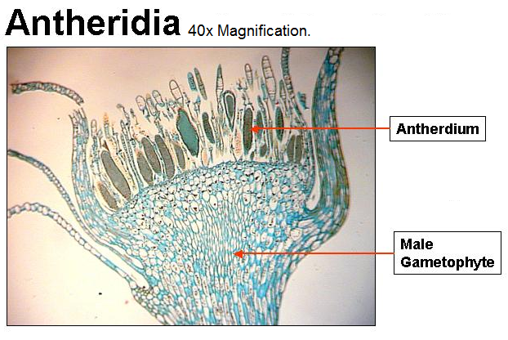
Kingdom: Plantae
Group: _______________
Phylum: ______________
Genus: _______________

STRUCTURE: ARCHEGONIA
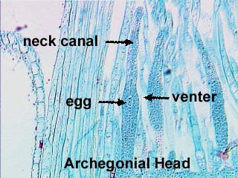
(Located on Prothalium)
Domain: ______________
Kingdom: _____________
Group: _______________
Phylum: ______________
Genus: _______________

STRUCTURE: INDUSIUM/
SPORANGIUM/SORUS
Domain: ______________
Kingdom: _____________
Group: _______________
Phylum: ______________
Genus: _______________

STRUCTURE: PROTHALIUM
WITH SPOROPHYTE
Domain: ______________
Kingdom: _____________
Group: _______________
Phylum: ______________
Genus: _______________

STRUCTURE: FERN
FROND WITH SORI
Domain: ______________
Kingdom: _____________
Group: _______________
Phylum: ______________
Genus: _______________

STRUCTURE: WHISKFERN
Domain: ______________
Kingdom: _____________
Group: _______________
Phylum: ______________
Genus: _______________

STRUCTURE: LYCOPHYTE
Domain: ______________
Kingdom: _____________
Group: _______________
Phylum: ______________
Genus: _______________

